# Assignment 5

# Task 1

Created a new class of Locations to store the data.

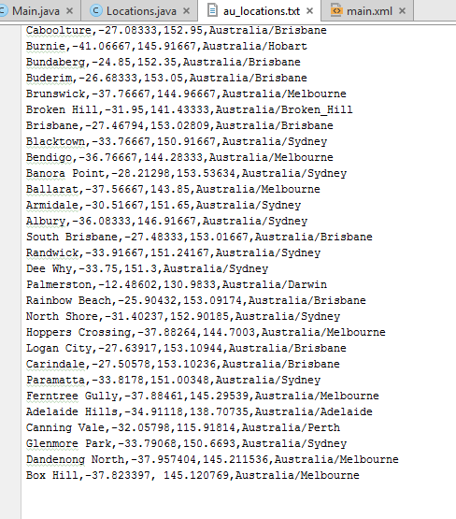

Saved the locations in a text file. Added Box Hill and Dandenong North to file.

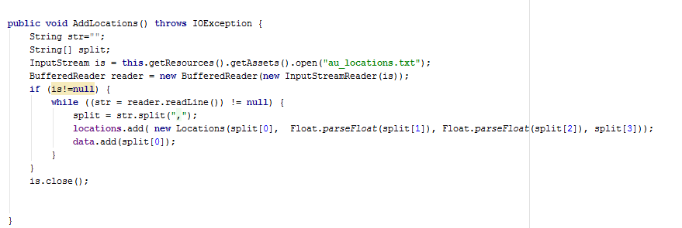

By using an Input stream and a buffer reader. I was able to read from the text file and save the data in a arraylist of locations.

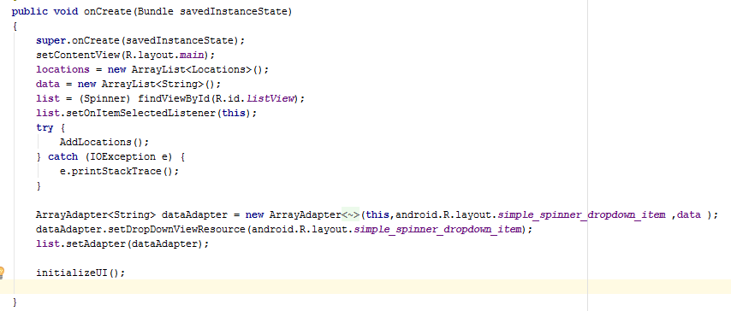

In Android, a drop down box is called a spinner. So after you read the file and add the locations. You then you need to create an arrayadapter that stores all the details to be inputted to the spinner.

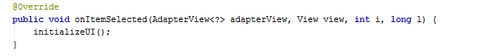

When you select an item in the spinner. It will automatically update any functionality using onitemselected.

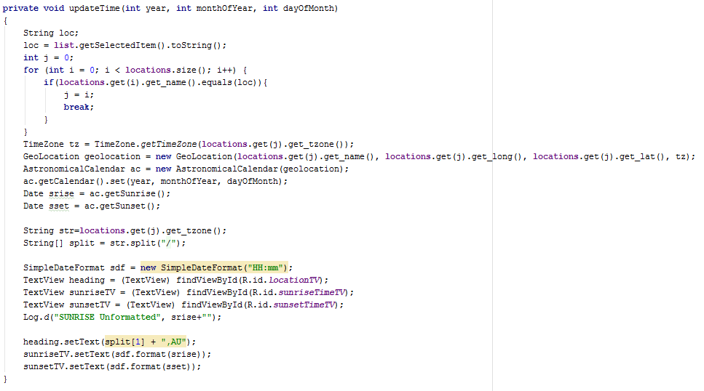

When you go to update the time it will grab the item from the spinner and then update the time zone and geo location to the data from the locations arraylist and then update the UI according to the location.

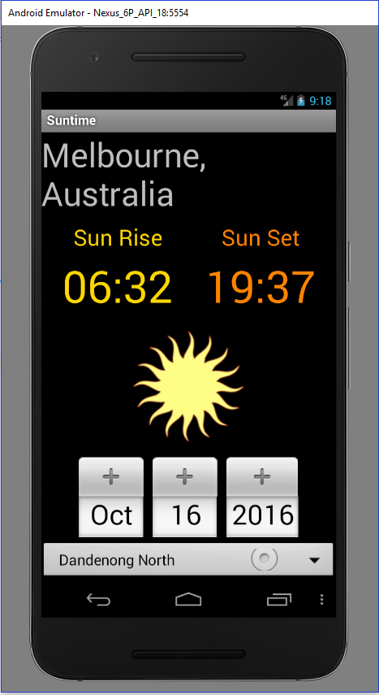

As you can see, there is a spinner on the bottom with the list of locations from the text file. It has changed to Dandenong North which is in the Melbourne time zone.

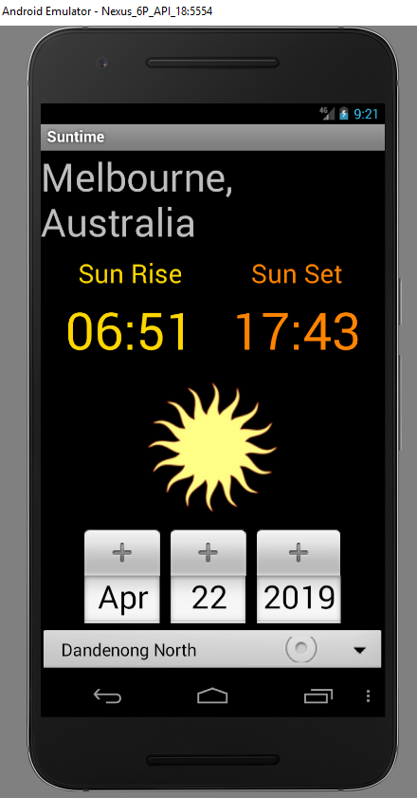

You can change the date and the UI will update to accommodate the changes

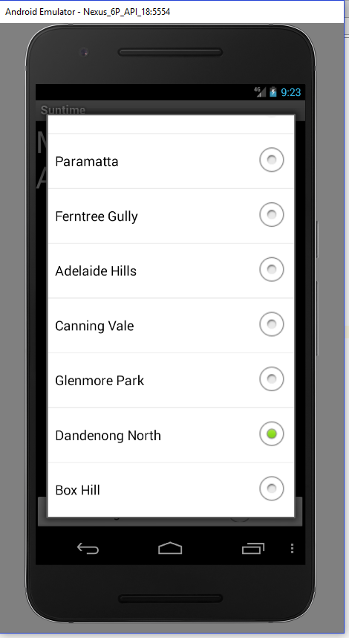

As you can see I have populated the spinner and you can select whichever location you want. When you change the item in the spinner it will defaul back to the day before today.

# 

# Task2

# Hi-Fidelity Testing

## Executive Summary

The Sun Rise App hi-fidelity testing was completed by 4 participants and all 4 were satisfied that it runs the way it was intended to.

## Introduction

The Sun Rise app is an idea which a user can access the time the Sun will rise/ set in a certain location. You will be able to look at the weather forecast for any past/ present/ future date that is valid.

The apps main features will include:

* Sun Rise/Set times
* Select from a pre-existing library of popular locations
* Generate a table of sun rise/ set times for a range of dates
* Share information via SMS and email
* Location Detection
* Google maps integration
* View weather forecast
* View sun rise/set times for various locations on a map

## User Stories

As a holiday maker, I want to see the sun rise/ set times in Wellington NZ so that can take pictures of the harbour

As a man fasting for 40 days due to religious believes, I want to find out the sun rise/set times so that I can have a spreadsheet of details from the 3 counties I will be in.

As a man fasting for 40 days due to religious believes, I want to email the spreadsheet so that I can have a copy to look once I close the app.

As a man fasting for 40 days due to religious believes, I want to print off the spreadsheet so that I can have a physical copy.

As a beach walker, I want to find out when the sun rises so I can ponder the meaning of live

As a camper, I want to use the in-built GPS system so that I can find out the sun rise/ set times due to poor signal.

As a camper, I want to email a spreadsheet so that I can find out the sun rise/ set times due to poor signal.

## Scenarios or Stories

When developing for the full app, A user story is more beneficial because people can relate to a good story more than a scenario. Even though stories might not be able to show a full feature list, they can portray enough information for people, so if they wish to research the app, they can then see what extra features they have which can increase the chances of people downloading and using the app.

## Hi-Fidelity Prototype

### Screen 01

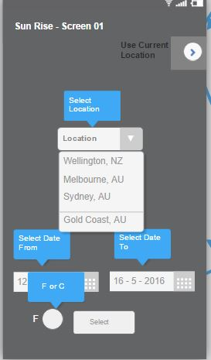On the home screen you have the ability to select a location and the dates you wish to see the sun rise and set. You have the ability to see the weather in Fahrenheit because the app is in Celsius since it’s being made in Australia and Celsius is the standard here. You also have the ability to click the fragment and go to google maps and see it for the current location.

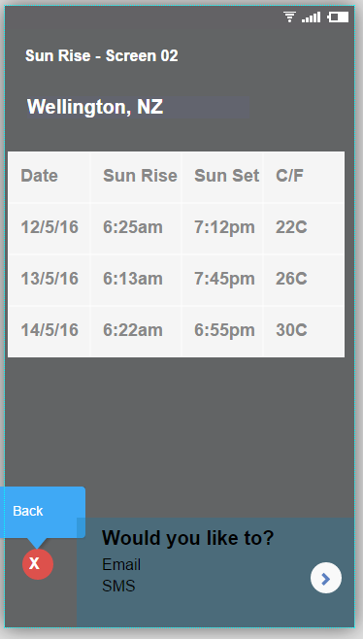

### Screen 02

After you have finished selecting your dates and location. It will setup a table with all the relevant data. Since Fahrenheit wasn’t selected it defaulted too Celsius. You also the ability to email or SMS the details. You also the capability to go back to main activity.

### Screen 3

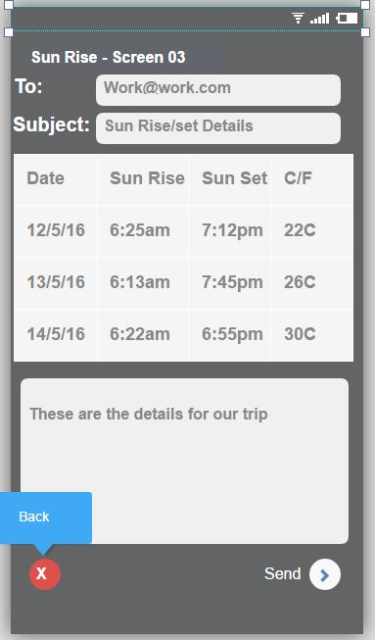

The activity populates the table and give you the ability to add people to the sending field and create a subject for the email. You can add anything you like to a small text field if you feel like it. You can send the email or go back to the pervious activity.

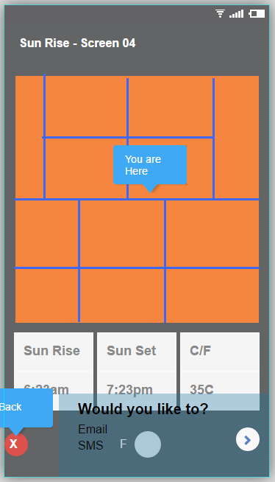

### Screen 04

If you decide to select the current location it will come up with the google maps api on the screen showing your location. Then underneath it. It displays the sun rise/set time with the current weather of the location. Change be changed to Fahrenheit. You have the ability to email or SMS it. You can go back to the main activity.

### Screen 05

When you select your current location. You have the power to change your location. When you do change your location it will update the sun rise/set to the appropriate times and update the weather.

### Screen 06

If you were interested in sending an SMS. It would take you to your SMS app and save the table as a JPEG and you can send it.

### User Scenarios and the UI

#### Scenario 1

All Brad has to do is go from Screen 01 -> Screen 02

#### Scenario 2

Sachin can complete his task by going from Screen 01 -> Screen 02 -> Screen 03

#### Scenario 3

Li has 2 options

1. Screen 01 -> Screen 02
2. Screen 01 -> Screen 05

#### Scenario 4

Justin and Mary can complete their task by going Screen 01 -> Screen 04 -> Screen 3